Pharmacy Residency (PGY1)

The Mission of Frankfort Regional Medical Center is “Above all else, we are committed to the care and improvement of human life”.

Our Vision is to be the first choice for health services by meeting the needs and exceeding the expectations of our patients, families, employees and physicians.

About Us
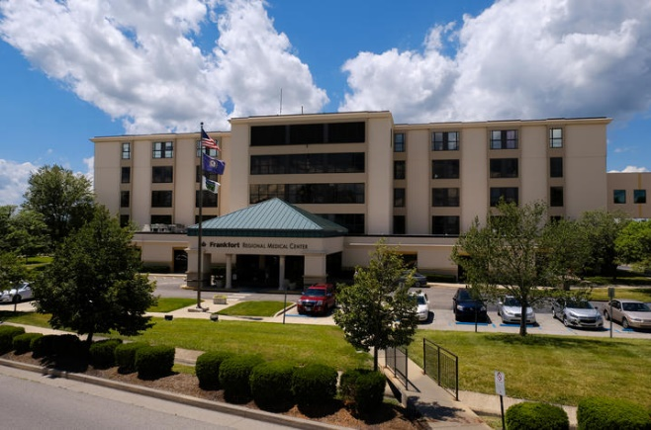
Frankfort Regional Medical Center
Frankfort Regional Medical Center is a 173-bed acute care facility located in Frankfort, KY that has received numerous awards and accolades for its quality of care including:

- Chest Pain Center with Primary PCI Accreditation
- Advanced Certification for Primary Stroke Center
- Verified Level III Trauma Center
- Commission on Cancer Accreditation
- Magnet Recognition Program®
- Healthgrades 2018 Patient Safety Excellence Award™
- Joint Commission Gold Seal
- Best Places to Work in Kentucky
Program Purpose

PGY1 pharmacy residency programs build on Doctor of Pharmacy (PharmD) education and outcomes to contribute to the development of clinical pharmacists responsible for medication-related care of patients with a wide range of conditions, eligible for board certification, and eligible for postgraduate year two (PGY2) pharmacy residency training. Residents will mentor pharmacy students and participate in a university affiliated teaching certificate program.

Program Structure

Residents are provided a challenging learning environment in an exceptional clinical pharmacy practice. This 12-month program currently accepts one full-time resident and is structured to align with ASHP accreditation requirements for PGY1 training while allowing individualization to enhance the resident’s long-term goals.

Rotations

- Orientation
- Staffing
- Surgery
- Internal Medicine
- Critical Care
- Infectious Disease
- Geriatrics
- Pediatrics
- Informatics
- Administration/Leadership
- Research

Staffing

Residents will be required to staff the inpatient pharmacy a minimum of two weekends per month and one evening shift per week as well as participate in the pharmacy on-call program. Additionally, the resident will be required to work one major holiday (Thanksgiving, Christmas or New Year’s Day) and one minor holiday (Fourth of July, Memorial Day, Labor Day). The residency director, pharmacy manager and resident will decide upon which holiday the resident will work at the start of the residency year.
All hours worked will comply with the pharmacy specific duty hours requirements for ASHP accreditation standards.
Teaching Opportunities

Residents will complete the University of Kentucky College of Pharmacy’s Teaching Certificate Program and precept IPPE and APPE students from UK College of Pharmacy and Sullivan University College of Pharmacy and Health Sciences.

Qualifications

- PharmD degree from an accredited college of pharmacy in the U.S.
- Eligible for licensure in the Commonwealth of Kentucky

Application Process

Interested candidates must submit an application through PhORCAS by the date designated on the application and participate in the Match process. The following documentation must be submitted with the application:
- CV
- Letter of Intent
- Transcript
- Three letters of recommendation

Requirements for Successful Completion of PGY1 Pharmacy Residency

- Compliance with all institutional and departmental policies
- Kentucky Pharmacy License obtained by September 1st
- BLS Certification
- ACLS Certification
- Successful completion of all learning experiences
- Successful completion of Teaching Certificate Program
- Successful completion and presentation of major research project
- Attendance and participation at ASHP or other national meeting
- Attendance and participation at Great Lakes Residency Conference or other regional meeting
- Attendance at all functions as required by the Residency Committee, the respective Residency Program Director and rotation preceptors
- Committee service as assigned
- Participation in recruitment of residents
- Presentation at Grand Rounds
- Participation in resident meetings, including the Kentucky Pharmacy Residency Network (KPRN)
- Active participation in the successful completion of a Medication Use Evaluation (MUE)
- Active participation in the development of a minimum of four publications
- Participation in clinical pharmacy on-call program
- Participation in teaching activities (co-preceptors for IPPE and APPE students on
rotation)
- Timely completion of all evaluations (within 10 days of completion of learning experience)
- At least 80% of required objectives must be ACH

Affiliation

This Program is affiliated with the University of Kentucky College of Pharmacy, Lexington, KY.

Program Contact

Lisa M. Hart, PharmD, BCPS, BCGP
PGY1 Pharmacy Residency Program Director
Frankfort Regional Medical Center
299 Kings Daughters Drive
Frankfort, KY 40601
Phone: (502) 226-7569
lisa.hart@hcahealthcare.com
frankfortregional.com

